https://app.kodnest.com/my-learning/class/19637735-869e-4096-ac31-d2e9e5799361/module/63afa337-4c35-4462-8ea7-1ae493508911/topic/bf3d8df2-93f6-446a-9a0d-41bff9107ff1/sub-topic/3231a558-6214-4d43-89d6-28a372895c64/layout/3/content

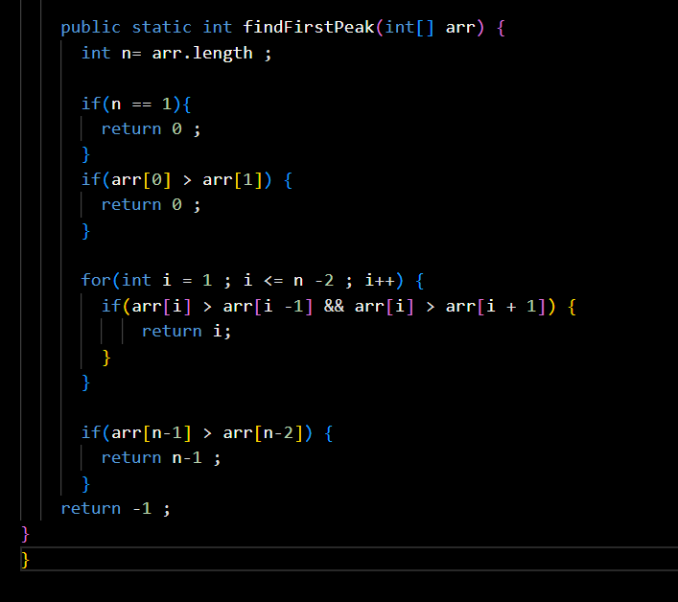

By binary search
